**CURRENCY EXCHANGE**

A Project Report

submitted in partial fulfillment of the requirements

for the degree of

**Bachelor of Technology**

in

**Information Technology**

by

**Nirmalya Datta, 2001610130048**

Under the Esteemed Guidance of

**Ms. Jasmeen Kaur**

and

**Mr. Pranjal Jain**



**Krishna Engineering College, Ghaziabad - 201007**

**Affiliated to**



**Dr. A. P. J. Abdul Kalam Technical University, Lucknow**

**December, 2022**

**UNDERTAKING**

I hereby declare that the work presented in this dissertation entitled **“CURRENCY EXCHANGE”*,*** in partial fulfillment of the requirement for the award of the degree of Bachelor of Technology in Information Technology, submitted to Dr. A. P. J. Abdul Kalam Technical University, Lucknow, is my work carried out during the period from *17/10/2022* to *12/12/2022* under the guidance of **Ms. Jasmeen Kaur** and **Mr. Pranjal Jain**, Krishna Engineering College, Ghaziabad.

The work reported in this dissertation has not been submitted by me for award of any other degree or diploma.

**Date:**

#### Place: Ghaziabad Nirmalya Datta 2001610130048

#### CERTIFICATE

# This is to certify that the Project report entitled “Currency Exchange” done by (Nirmalya Datta, 2001610130048), is carried out by him at Krishna Engineering College, Ghaziabad under my guidance. The matter embodied in this project work has not been submitted earlier for the award of any degree or diploma to the best of my knowledge and belief.

Date: __________________

……………………………. …………………………….

**Ms. Jasmeen Kaur Mr. Pranjal Jain**

Mini-Project Coordinator Mini-Project Coordinator

…………………………….

**Prof. (Dr.) Deepak Yadav**

Head of Department of Information Technology

**ACKNOWLEDGMENT**

I would like to take this opportunity to express my deep sense of gratitude to all individuals who helped me directly or indirectly during this project work.

Firstly, I would like to thank my supervisors, Ms. Jasmeen Kaur and Mr. Pranjal Jain for being great mentors. The success and final outcome of the project required a lot of guidance and assistance. I am extremely fortunate to have got their advice, encouragement and criticism all along the completion of my project work. It has been a privilege working with them from last two months. They always helped me during my project and many other aspects related to academics. I am grateful to them for providing such a support and guidance through their busy schedule. I owe them my profound gratitude for taking keen interest in my project work and providing all necessary information for developing a good project.

I express my heartfelt gratitude towards Prof (Dr.) Deepak Yadav, Head of IT Department for granting me permission to work on this project.

I also express my gratitude and thanks to my fellow students, some non-teaching staff for their quick help and expert opinions for completing this project.

**Nirmalya Datta, 2001610130048**

**TABLE OF CONTENTS**

Candidate’s Declaration (ii)

Certificate (iii)

Acknowledgment (iv)

List of Figures (vi)

Abstract (vii)

**Chapter 1. Introduction**

1.1 Software Requirements

1.2 Hardware Requirements

**Chapter 2. Software Tools Used**

2.1 IDE

2.2 Browser

2.3 Database

**Chapter 3. Technologies Used**

3.1. HTML for creating web page

3.2. CSS for the styles and colors

3.3. JavaScript for the functionality

3.3. Servlets for creating dynamic web pages and displaying output

3.3. JDBC for establishing connection with the database

**Chapter 4. Screenshots**

**Chapter 5. Conclusion**

**References**

**LIST OF FIGURES**

|  |  |  |
| --- | --- | --- |
| **Figures** | **Title** | **Page No.** |
|  | **USD to NPR** | **18** |
|  | **Switching between USD and NPR** | **19** |
|  | **Currency Drop Down List** | **20** |
|  | **USD to INR** | **21** |

#### ABSTRACT

Currency Converter System Web Application is mainly developed for the user to get the live currency status of all the country’s currencies exchange in one app. The main aim of this application is to provide a web-based interface for exchanging money from one currency (say $) to another currency (say Rs).

The application is developed to represent dynamic functionality as that of currency converter. This helps the user to know about the currency value update regularly with advanced features and functionality. Major functions and features have been integrated to enhance the performance of the application to give better results for the users. Currency Converter Web Application Source Code gives accurate corresponding exchange result value in their user hand by utilizing online information sources. It is used in knowing the currency value of different countries and make available to common people quickly and easily.

They can be utilized anywhere and at any time. It helps travelers who are travelling across the borders. It can be further developed by including more currency option and by showing currency value table and a graphical representation for delivering exact information to the users. In this Currency Exchange Web App, users are provided with an option to select the type of conversion, i.e. from “this” currency to “that” currency. This simple feature allows users to enter amount to be converted (say currency in Dollars), and display the converted amount (say currency in Rupees). The user can register their account with their valid mail id and password, the account confirmation is sent through the user mail. All country details with their flag, currency name, and currency rate. It is easy to convert the currency updates from one to another. Converter Android App Source Code has a navigation menu where the options like home, favorite, chart, setting-Theme, share app, history, decimal digits.

#### INTRODUCTION

Currency converter is a tool used to convert one country’s currency to another. In this project by the knowledge of usage of currency converter a program is designed in JAVA language. In this Currency Converter application, it is going to display a web page where you can choose to display the converter or the exchange rate of one currency with all other currencies in the form of table. In the converter you are given a choice to choose two currency names from the list of currency names displayed.

A cash converter is programming code that is intended to change one money into another all together over to check its relating esteem. The code is commonly a piece of a site or it frames a portable application and it depends on current market or bank trade rates. To change over one cash into another, a client enters a measure of cash (for example '1000') and picks the cash he/she wishes to check the money related estimation of (for example 'US Dollar'). From that point forward, the client chooses one, or some of the time a few different monetary forms, he/she might want to see the outcome in. The application programming at that point computes and shows the comparing measure of cash. Money converters expect to keep up continuous data on current market or bank trade rates, so the determined outcome changes at whatever point the estimation of both of the segment monetary standards does. They do as such by interfacing with an information base of current cash trade rates. The recurrence at which cash converters update the trade rates they use differs.

The money change programming ascertains the rates as decimal point numbers with ordinarily 4 decimals after the comma. Some may ascertain the transformation rates with more decimals inside yet just 4 are shown. This is identified with exactness, programming disguise and how the global business sectors work, where most changes have 4 decimal spots, albeit some money matches additionally have 5. Most money converters utilize around 4. A money transformation expense is a charge required by the credit or check card instalment processor or ATM organization to change one cash over to another as a component of a monetary exchange.

An unfamiliar exchange expense is a charge required by your credit or check card guarantor or ATM network on a similar exchange. The unfamiliar exchange expense may incorporate the cash change charge, contingent upon whether the card guarantor or ATM network gives that expense to you. (A few cards don't charge unfamiliar exchange expenses.) Dynamic cash change (DCC) is normally more expensive than money transformation through the Visa processor, yet it lets you see the expense of your exchange in U.S. dollars when you cause it instead of when you to get your Visa bill.

This application is to be developed to represent dynamic functionality of currency converter. The application can simultaneously convert to currency using an online information source. Different countries use different currencies and these currencies change daily compared to each other. Those who have transferred money (one currency to another) from one country to another must be updated with the latest currency exchange rates in the market. With this in mind, the Currency Converter project has been created. This is just an app development like a calculator using Java.

In this application, there are regular updates about each country's currency by which it reflects the current currency market value and conversion rate. Such an application can be used by any user, but it is mainly useful for business, shares and finance related areas where money transfer and currency exchange take place daily.

In this currency converter app, users are given the option to choose the type of conversion, i.e. "this" currency to "to" currency. This simple feature allows users to enter the amount to convert (say currency in dollars) and display the converted amount (say currency in euros). Real Time Currency Converter converts user-assigned currency into just one currency. It shows the real-time rate of the currency if the Internet provides Internet connectivity and the final updated price of the currency if the Internet does not provide Internet connectivity.

* 1. **SOFTWARE REQUIREMENTS**
* JAVASCRIPT for functionality
* HTML for creating web page
* CSS for designing the pages
  1. **HARDWARE REQUIREMENTS**
* PROCESSOR – INTEL CORE PROCESSOR
* OPERATING SYSTEM – WINDOWS VISTA, WINDOWS 7,10,11
* MEMORY – 1 GB RAM OR MORE
* HARD DISK SPACE – MINIMUM 3 GB

#### SOFTWARE TOOLS USED

* **IDE (Integrated Development Environment)**

Java IDE **(Integrated Development Environment)** is a software application that enables users to **write** and **debug** Java programs more easily. Most IDEs have features such as syntax highlighting and code completion that helps users to code more easily. Usually, Java IDEs include a **code editor, a compiler, a debugger,** and **an interpreter** that the developer may access via a single graphical user interface. Java IDEs also provide language-specific elements such as **Maven, Ant building tools, Junit,** and **TestNG for testing.**

The [Java](https://www.javatpoint.com/java-tutorial) IDE or Integrated Development Environment provides considerable support for the application development process. Through using them, we can save time and effort and set up a standard development process for the team or company. **Eclipse, NetBeans,**[IntelliJ IDEA](https://www.javatpoint.com/intellij-idea-tutorial), and many other IDEs are most popular in the Java IDE's that can be used according to our requirements. In this topic, we will discuss the best Java IDE's that are used by the users.

## The following are the best Java IDEs that are mostly used in the world:

* [Eclipse](https://www.javatpoint.com/java-ides#Eclipse)
* [NetBeans](https://www.javatpoint.com/java-ides#NetBeans)
* [IntelliJ IDEA](https://www.javatpoint.com/java-ides#IntelliJ-IDEA)
* [BlueJ](https://www.javatpoint.com/java-ides#BlueJ)
* [JCreator](https://www.javatpoint.com/java-ides#JCreator)
* [JDeveloper](https://www.javatpoint.com/java-ides#JDeveloper)
* [MyEclipse](https://www.javatpoint.com/java-ides#MyEclipse)
* [Greenfoot](https://www.javatpoint.com/java-ides#Greenfoot)
* [DrJava](https://www.javatpoint.com/java-ides#DrJava)
* [Xcode](https://www.javatpoint.com/java-ides#Xcode)
* [Codenvy](https://www.javatpoint.com/java-ides#Codenvy)
* **Browser**

**Microsoft Edge** is a [proprietary](https://en.wikipedia.org/wiki/Proprietary_Software), [cross-platform](https://en.wikipedia.org/wiki/Cross-platform_software) [web browser](https://en.wikipedia.org/wiki/Web_browser) created by Microsoft. It was first released in 2015 as part of [Windows 10](https://en.wikipedia.org/wiki/Windows_10) and [Xbox One](https://en.wikipedia.org/wiki/Xbox_One) and later [ported](https://en.wikipedia.org/wiki/Ported) to other platforms as a fork of [Google](https://en.wikipedia.org/wiki/Google)'s [Chromium open-source project](https://en.wikipedia.org/wiki/Chromium_(web_browser)): [Android](https://en.wikipedia.org/wiki/Android_(operating_system)) and [iOS](https://en.wikipedia.org/wiki/IOS), [MacOS](https://en.wikipedia.org/wiki/MacOS), older Windows versions ([Windows 7](https://en.wikipedia.org/wiki/Windows_7) and later), and most recently [Linux](https://en.wikipedia.org/wiki/Linux). It was created as the successor to [Internet Explorer](https://en.wikipedia.org/wiki/Internet_Explorer) (IE).

Edge was initially built with Microsoft's own proprietary [browser engine](https://en.wikipedia.org/wiki/Browser_engine), [EdgeHTML](https://en.wikipedia.org/wiki/EdgeHTML" \o "EdgeHTML), and their [Chakra](https://en.wikipedia.org/wiki/Chakra_(JavaScript_engine)) [JavaScript engine](https://en.wikipedia.org/wiki/JavaScript_engine). In late 2018, it was announced that Edge would be completely rebuilt as a [Chromium](https://en.wikipedia.org/wiki/Chromium_(web_browser))-based browser with [Blink](https://en.wikipedia.org/wiki/Blink_(browser_engine)) and [V8](https://en.wikipedia.org/wiki/V8_(JavaScript_engine)) engines. The new Edge was publicly released in January 2020, and on Xbox platforms in 2021. Microsoft has since terminated security support for the original browser (now referred to as Microsoft Edge Legacy), and in [Windows 11](https://en.wikipedia.org/wiki/Windows_11) it is the default web browser (for compatibility with [Google Chrome](https://en.wikipedia.org/wiki/Google_Chrome)).

* **Database**

**JDBC** or **Java Database Connectivity** is a Java API to connect and execute the query with the database. It is a specification from Sun microsystems that provides a standard abstraction (API or Protocol) for java applications to communicate with various databases. It provides the language with java database connectivity standards. It is used to write programs required to access databases. JDBC, along with the database driver, can access databases and spreadsheets. The enterprise data stored in a relational database (RDB) can be accessed with the help of JDBC APIs. Enterprise applications created using the JAVA EE technology need to interact with databases to store application-specific information. So, interacting with a database requires efficient database connectivity, which can be achieved by using the [ODBC](https://www.geeksforgeeks.org/difference-odbc-jdbc/)(Open database connectivity) driver. This driver is used with JDBC to interact or communicate with various kinds of databases such as Oracle, MS Access, MySQL, and SQL server database.

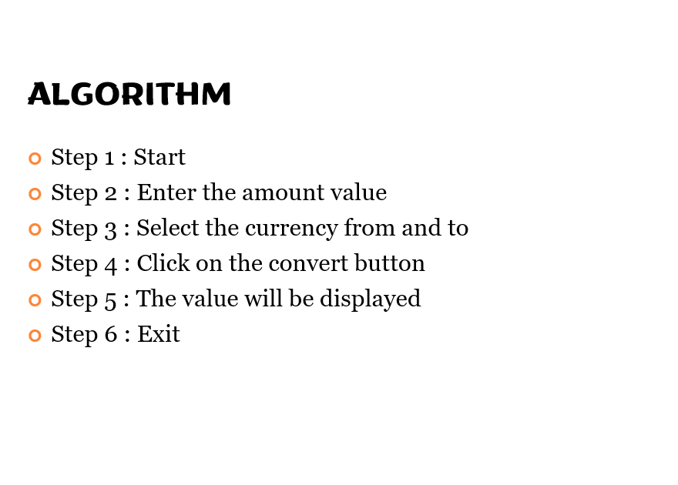

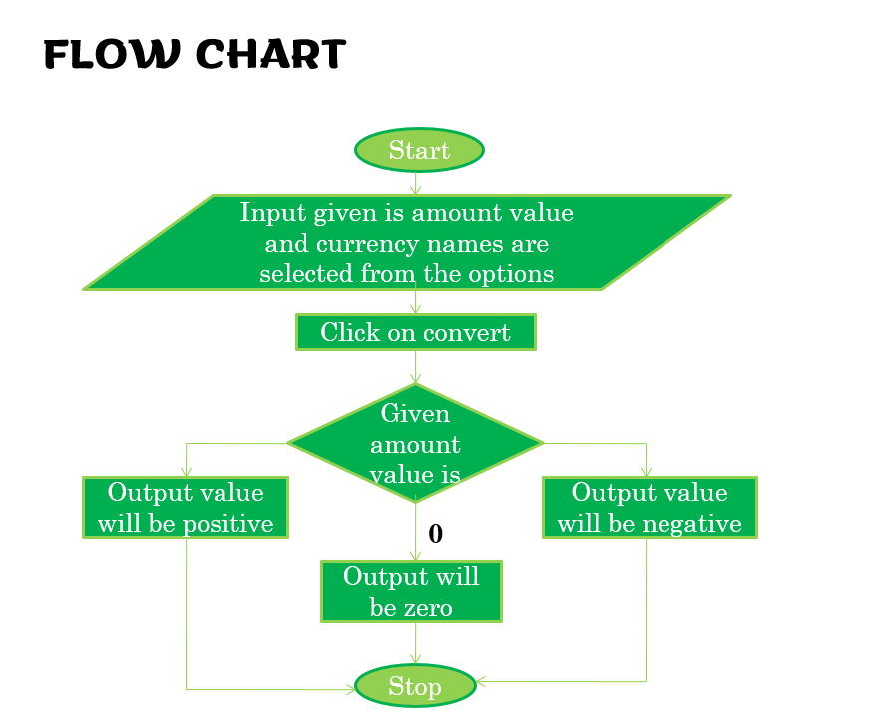

#### TECHNOLOGIES USED

* **HTML (Hyper Text Markup Language)**

HTML (Hyper Text Markup Language) is the code that is used to structure a web page and its content. For example, content could be structured within a set of paragraphs, a list of bulleted points, or using images and data tables. As the title suggests, this article will give you a basic understanding of HTML and its functions. Web Page: A web page is a document which is commonly written in HTML and translated by a web browser. A web page can be identified by entering an URL. A Web page can be of the static or dynamic type. With the help of HTML only, we can create static web pages 1) It is a very easy and simple language. It can be easily understood and modified. 2) It is very easy to make an effective presentation with HTML because it has a lot of formatting tags. 3) It is a markup language, so it provides a flexible way to design web pages along with the text. 4) It facilitates programmers to add a link on the web pages (by html anchor tag), so it enhances the interest of browsing of the user. 5) It is platform-independent because it can be displayed on any platform like Windows, Linux, and Macintosh, etc.

* **CSS (Cascading Style Sheets)**

Cascading Style Sheets (CSS) is a programming design language that includes all relevant information relating to the display of a webpage. CSS defines the style and formatting of a website or page, including the layout, colors, fonts, padding (the space around each element) and more.

Advantages of CSS:

• CSS saves time − You can write CSS once and then reuse same sheet in multiple HTML pages. You can define a style for each HTML element and apply it to as many Web pages as you want.

• Pages load faster − If you are using CSS, you do not need to write HTML tag attributes every time. Just write one CSS rule of a tag and apply it to all the occurrences of that tag, so less code means faster download times.

• Easy maintenance − To make a global change, simply change the style, and all elements in all the web pages will be updated automatically.

• Superior styles to HTML − CSS has a much wider array of attributes than HTML, so you can give a far better look to your HTML page in comparison to HTML attributes.

• Multiple Device Compatibility − Style sheets allow content to be optimized for more than one type of device. By using the same HTML document, different versions of a website can be presented for handheld devices such as PDAs and cell phones or for printing.

• Global Web Standards − Now HTML attributes are being deprecated and it is being recommended to use CSS, so it’s a good idea to start using CSS in all the HTML pages to make them compatible to future browsers.

* **Javascript**

JavaScript is a scripting or programming language that allows you to implement complex features on web pages — every time a web page does more than just sit there and display static information for you to look at — displaying timely content updates, interactive maps, animated 2D/3D graphics, scrolling video jukeboxes, etc. — you can bet that JavaScript is probably involved. It is the third layer of the layer cake of standard web technologies, two of which (HTML and CSS) we have covered in much more detail in other parts of the Learning Area. The HTML <script> tag is used to specify a client-side script. It may be an internal or external JavaScript which contains scripting statements hence we can place <script> tag within <body> or <head> section. It is mainly used to manipulate images, form validation and change content dynamically. JavaScript uses document.getElementById() method to select an HTML element.

The first popular web browser with a graphical user interface, Mosaic, was released in 1993. Accessible to non-technical people, it played a prominent role in the rapid growth of the nascent World Wide Web. The lead developers of Mosaic then founded the Netscape corporation, which released a more polished browser, Netscape Navigator, in 1994. This quickly became the most-used. During these formative years of the Web, web pages could only be static, lacking the capability for dynamic behavior after the page was loaded in the browser. There was a desire in the flourishing web development scene to remove this limitation, so in 1995, Netscape decided to add a to embed scripting language to Navigator. They pursued two routes to achieve this: collaborating with Sun Microsystems the Java programming language, while also hiring Brendan Eich to embed the Scheme language.

Netscape management soon decided that the best option was for Eich to devise a new language, with syn- tax similar to Java and less like Scheme or other extant scripting languages. Although the new language and its interpreter implementation were called LiveScript when first shipped as part of a Navigator beta in September 1995, the name was changed to JavaScript for the official release in December.

The choice of the JavaScript name has caused confusion, implying that it is directly related to Java. At the time, the dot-com boom had begun and Java was the hot new language, so Eich considered the JavaScript name a marketing ploy by Netscape.

* **Visual Studio Code**

Visual Studio Code is a code editor in layman’s terms. Visual Studio Code is “a free-editor that helps the programmer write code, helps in debugging and corrects the code using the Intellisense method”. In normal terms, it facilitates users to write the code in an easy manner. Many people say that it is half of an IDE and an editor, but the decision is up to the coders. Any program/software that we see or use works on the code that runs in the background. Traditionally coding was used to do in the traditional editors or even in the basic editors like notepad! These editors used to provide basic support to the coders.

Some of them were so basic that it was very difficult in writing basic English level programs in them. As time went by, some programming languages needed a specific framework and support for further coding and development it, which was not possible using these editors. VI Editor, Sublime Text Editor, is one of the many kinds of editors that came into existence. The most prominent and which supports almost every coding language is VS code.

#### SCREENSHOTS

**USD to NPR**

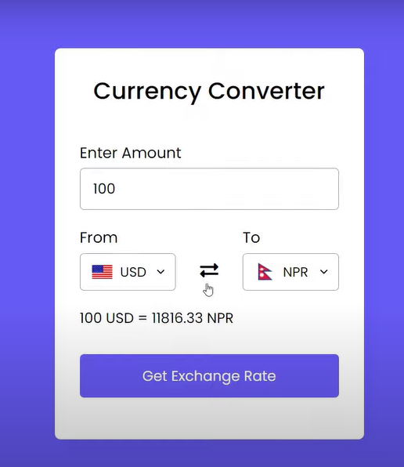

**Switching between USD and NPR**

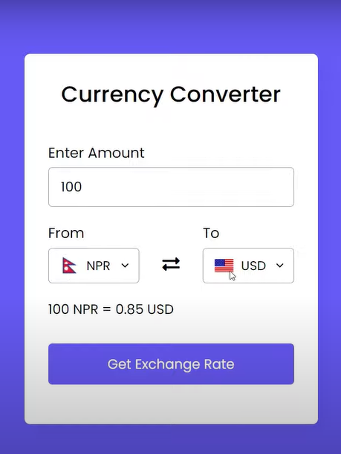

**Currency Drop Down List**

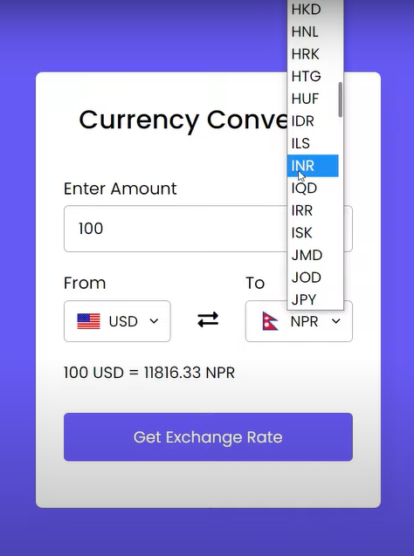

**USD to INR**

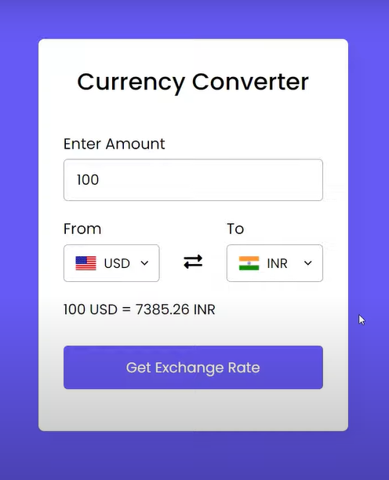

#### CONCLUSION

The Currency Exchange app will involve reading user input And Values.

All the currency are included in this Application, which you have to choose to convert or exchange any currency you want.

This app should take an input of any currency to exchange immediately convert it into another currency of your choice. Some popular currencies you can consider using include the following: [Euro, Yen, Rupee, Bitcoin etc.]

#### REFERENCES

**1. HTML https://www.w3schools.com/html**

**2. CSS https://www.w3schools.com/css**

**3. JAVA https://www.w3schools.com/java**

**4. Javascript https://www.w3schools.com/js**

**5. GeeksforGeeks** [**https://www.geeksforgeeks.org**](https://www.geeksforgeeks.org)

**6. YouTube https://www.youtube.com**